**CS310 Data Structures and Algorithms Spring 2020**

**Homework 3 & 4**

**40 Points**

**Name: Stephen Giang**

1. (8 Points) Assume this tree is a **Binary Search Tree** even though you cannot see what the keys and values are at the nodes (the letters we write below are just “names” for the nodes for the purpose of answering the questions).

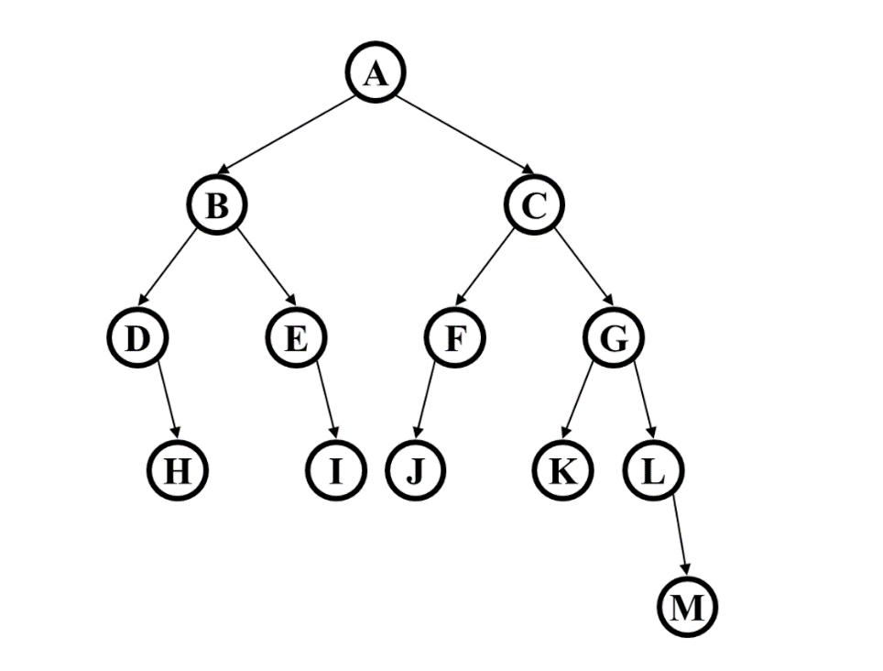

* 1. The value of H is greater than the value of I (True/False) **False**
  2. This Binary Search Tree is complete (True/False) **False**
  3. What is the height of the tree? **Four**
  4. What is the maximum number of nodes that could be added to the tree without increasing its height? **Eighteen**

1. (4+4 Points) Suppose there is a **Binary Min-Heap** with exactly 4 nodes, containing items with priorities 3, 9, 11, and 15.
   1. Show every possible binary min-heap that could match this description. For each, draw the appropriate tree and the array representation. (You can show just the priorities, not the corresponding items.)
   2. For one of your answers to part (a), show what happens with 4 deleteMin operations. Clearly indicate which heap you are starting with and show the heap after each deleteMin. You can just draw the tree (not the array) after each step.

**Delete 1**

Replace root with last leaf

Swap root with smallest of root’s children

Swap root with smallest of root’s children

**Delete 2**

Replace root with last leaf

Swap root with smallest of root’s children

**Delete 3**

Replace root with last leaf

**Delete 4: No More Nodes**

1. **(8 points)** For each of the following situations, name the best sorting algorithm we studied. (For one or two questions, there may be more than one answer deserving full credit, but you only need to give one answer for each.)

The array is mostly sorted already (a few elements are in the wrong place).

1. You need an O(n log n) sort even in the worst case and you cannot use any extra space except for a few local variables.

**Heap Sort – We only need to heapify half of the tree but need to do it n times to fully sort the array. So it is of O(n log n).**

1. The data to be sorted is too big to fit in memory, so most of it is on disk.

**Merge Sort – It can partition the entire data set into many smaller sub arrays and then sort from there.**

1. You have many data sets to sort separately, and each one has only around 10 elements.

**QuickSort – It can sort each data set approximately of O(n) because log10 = 1.**

1. Instead of sorting the entire data set, you only need the k smallest elements where k is an input to the algorithm but is likely to be much smaller than the size of the entire data set.

**Quick Sort – It partitions the array for all elements less than k to the left, and greater than to the right. So it could have all the smallest elements after 1 pass.**

1. **(5 Points)** Draw the **binary max heap** that results from inserting 6,12,7,10,17,5,15 in that order into an initially empty binary min heap. You do not need to show the array representation of the heap. Draw all intermediate trees.

1) We check the first far right parent node with its children, and swap if its largest child is bigger than itself.

3) We check the root with its children, and swap if its largest child is bigger than itself.

2) We check the far left parent node with its children, and swap if its largest child is bigger than itself.

4) We check the recently swapped node with its children, and swap if its largest child is bigger than itself.

1. (4+4 Points)

• Describe the most time-efficient way to implement the operations listed below. Assume no duplicate values and that you can implement the operation as a member function of the class – with access to the underlying data structure, including knowing the number of values currently stored (N).

• Then, give the tightest possible upper bound for the worst case running time for each operation in terms of N.

**For any credit, you must explain why it gets this worst case running time.**

1. Given a binary min heap, find which value is the minimum value and delete it.

**Because it is a Binary Min Heap, then the root is going to contain the minimum. So all you need to do is replace the root with last node added. Then downHeap to make sure the binary min heap is still following the binary min heap rules. Because of the downHeap, the worse case running time is 0(logN). The downHeap has to traverse all the way down the tree with height of logN.**

1. Given a binary search tree, find which value is the minimum value and delete it.

**Because it is a binary search tree, all left childs are going to be less than their parent, so all we need to do is traverse all the way down to the far most left leaf. Then we need to check if it has a right child. If so, we need to set its right child’s parent to be its grandparent. If no right child, then we need to set its parent node to have no children. The traversing makes it check each row, so its runtime will be O(logN), but if the entire tree is left skewed, then it can run to O(N)**